**Library Management System using**

**Spring Boot**

Book endpoints:

-**Get all books:**

GET /api/books

Response:

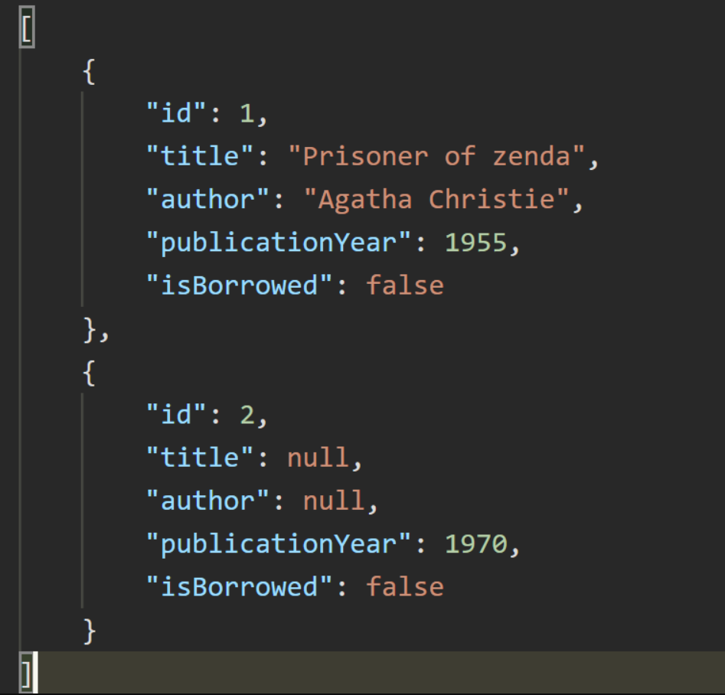

**- Get a book by ID:**

GET /api/books/{id} Response:

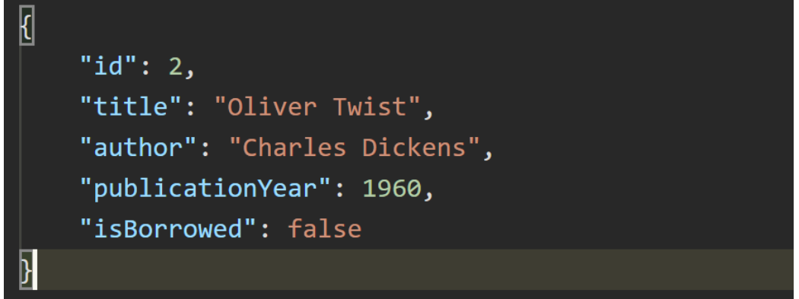

**- Add a new book:**

POST /api/books/add

Request Body:

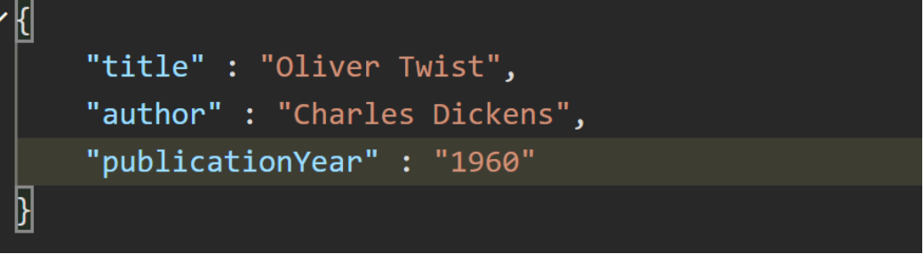

Response:

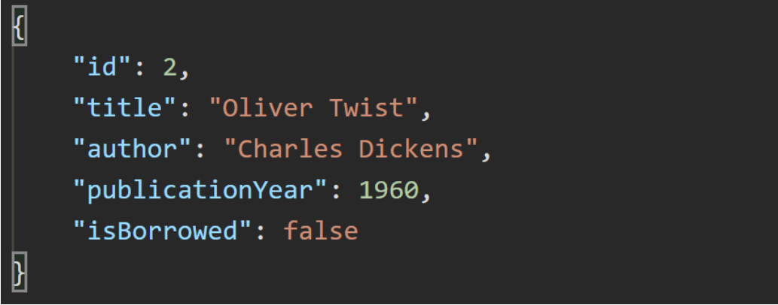

**- Edit a existing book:**

PUT /api/books/edit/{id}

Request Body:

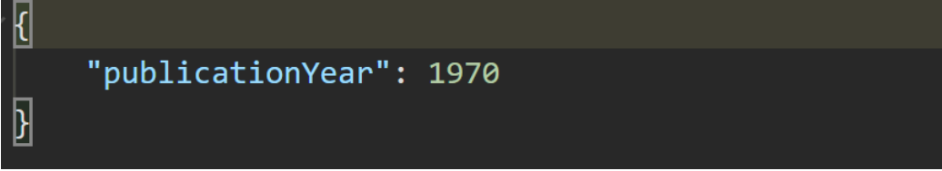

Response:

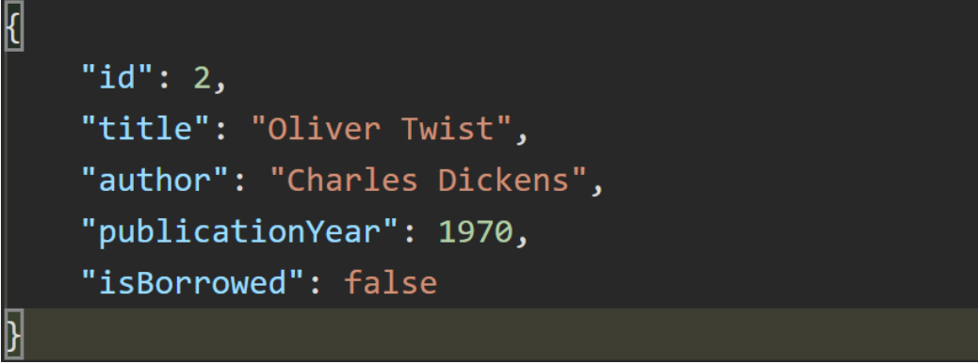

DELETE /api/books/delete/{id}

Response:



**Patron Endpoints**

**- Get all patrons:**

GET /api/patrons

Response:

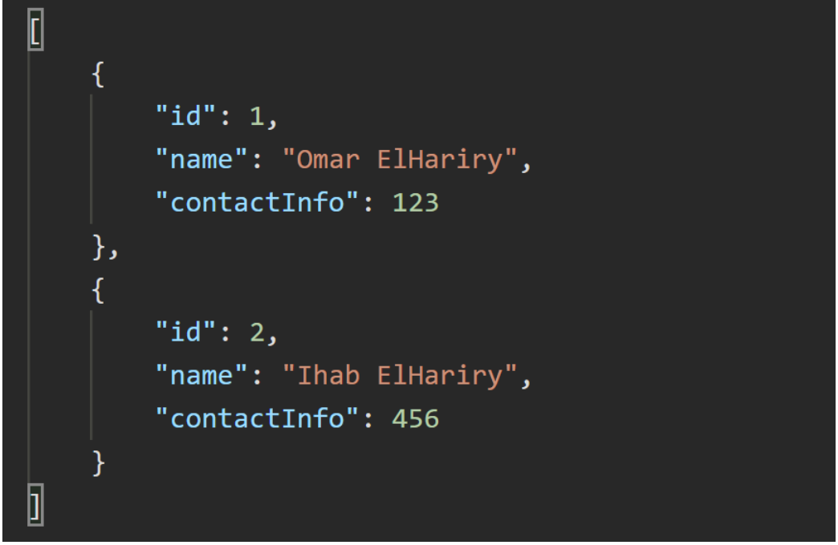

**- Get a patron by ID:**

GET /api/patron/{id} Response:

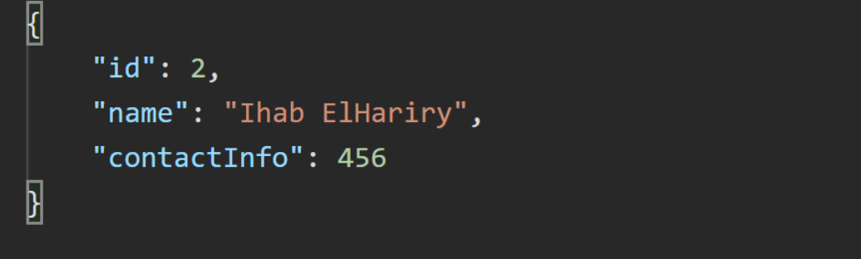

**- Add a new patron:**

POST /api/patron/add

Request Body:

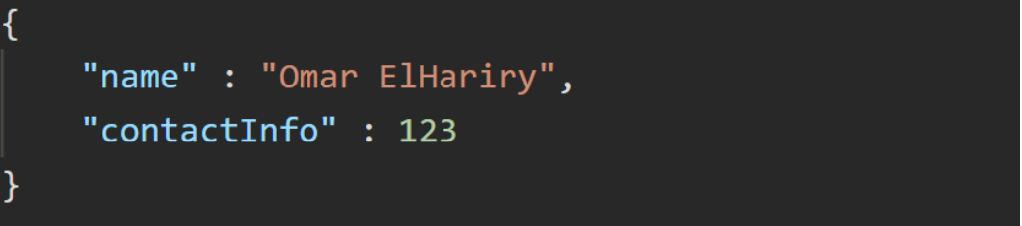

Response:

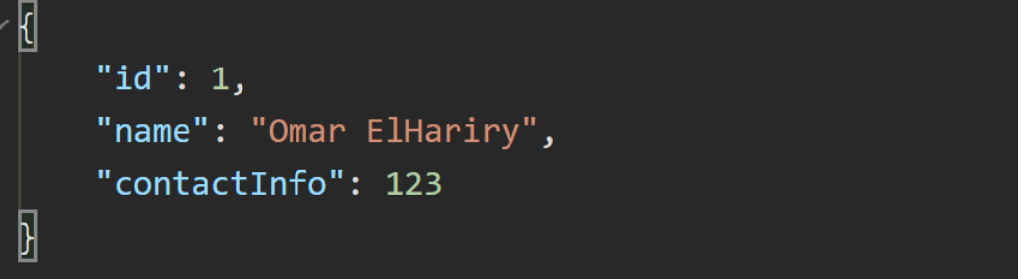

**- Edit a existing patron:**

PUT /api/patron/edit/{id} Request Body:

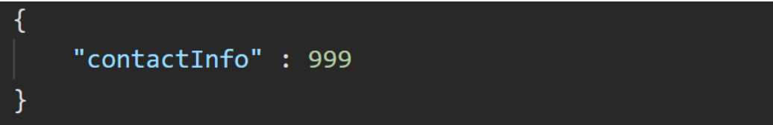

Response:

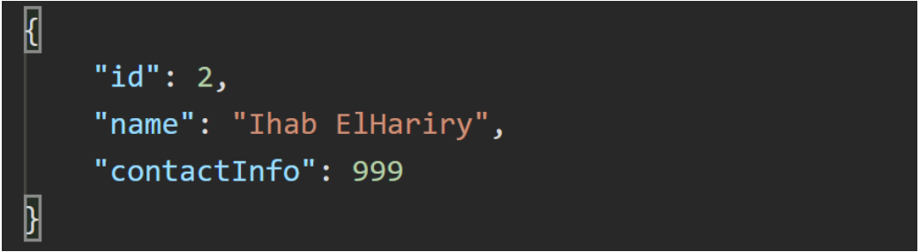

**- Delete a patron:**

DELETE /api/patron/delete/{id}

Response:



**Borrowing Record Endpoints**

**- Borrow a book:**

POST api/borrow/{bookId}/patron/{patronId}

Response:

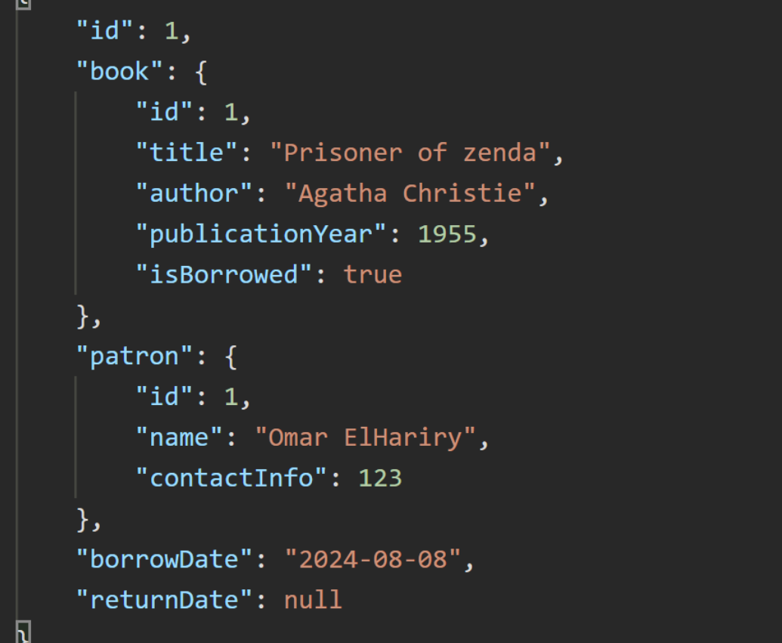

**- Return a book:**

PUT api/return/{bookId}/patron/{patronId}

Response:

